OBJECT ORIENTED DESIGN
PROJECT PROPOSAL

Epic-Monopoly

SUSTech

Ziqiang Li 11510352
Yulian Mao 11510085
Xizi Ni 11510602
Yilin Zheng 11510506
Chenyu Zhou 11510374

Oct. 2017

Abstract
In this project, we concentrate on developing a new monopoly game mechanics which is a online web game. We add economy factor in the game to make the game close to reality. The economy factor will change randomly in a period and influence the house price, station price and chance probability. In order to increase game enjoyment, we use dynamic map in the game. The map will change period to repick the fate of players falling behind. Besides country element, we also add new alliance element, for example, the tax and warfare depends on country’s policy. The game difficult level depends on the fluctuation of the game parameter. We build enterprisers mid entering rules. The enterprisers allowed entered after the game began and when no one has more than 50% real estate, the initial money of enterprisers depends on the game turns.

Background
Mr. Wang, Mr. Li, Mr. Son and Mr. Trump, who are entrepreneurs from China, Japan and the US wants to play a game to decide who is the smartest in dealing business. They play a new Monopoly game with more variable and inexact parameter. Besides, entrepreneurs are allowed to join in mid. Of course, They choose hard mode. Mr. Wang choose buy more properties as soon as possible for larger probability that opponent step into him properties. Mr. Trump choose to buy expensive properties and build more rooms for luxury rental. Mr. Son invest steady. And Mr. Li choose as soon as buy the utilities. In mid, Mr. Ma join in. There are Large volatility under Hard difficulty, Mr. Trump spend is too much money to upgrade the properties leading to cash shortage, and then step into the opponent property. However, mortgage money cannot pay off the debt. Finally, Mr. Trump bankruptcy. Mr. Ma have many cash, and he auction into Mr. Trump’s properties from the bank at a relatively low price. Mr. Ma take a place so quickly. Other entrepreneurs have a plan for them own benefit. So, they agree to form an alliance in order to protect mutual interest to suppress Mr. Ma. The game is getting more and more interesting.

Current Problems
The biggest problem of Monopoly game is that it is contradict to the real-life economy. The value of real estate is static which is impossible in reality. In the old time (Monopoly published in 1935), the game design cannot dynamic change the value of all the real estate in Monopoly. However, the development of web application, dynamic changes of the parameters of the game are available.
Second, there are not loyalty program in Monopoly. Rent of real estate stays still in regard of how many times a player paid for the rent. In reality, there are some reward for the renter for paying many times.
Also, the sequence of map cannot change in Monopoly, which must responsible for the loss of many players. If a player buys all the real estate for continues two color blocks, it will have much more chance to win this game. On the other words, the rest of players will lose the fate of winning the game.
Besides, because of lack of rewarding for cooperation, players seldom cooperate with each other. In Monopoly, players always play alone, complete with the rest of players. While on reality, enterprisers always cooperate with each other for the profit.

Solution & Silver Bullet
- Economy Factor
On the one hand, to be more reasonable to change the value of all real estate, card and value of other object. On the other hand, to increase the equality of all game parameters setting. Economy Factor (EF) is introduced to the New Monopoly. For a specific period, EF will change between a certain range, and it will have influence on the rent, pricing of the house, etc.
- Dynamic Map
The sequence of spot in the New Monopoly will change in a specific period, to repick the fate of players who falling behind. In order to unified the map, the change of color blocks, stations and utilities will be control by some rules.
- Country & Alliance
For the cooperation problem, countries and alliances are introduced to the New Monopoly. Every player will assign to one countries and corresponding alliances. The trade and rent between the member of alliances will make discount. And some new event will add to opportunity, to add more fun. In reality, tax and warfare differ depends of country’s policy. Therefore, the tax and some of cards in society chest will depends on which country the player belongs.
- Difficulty Setting
Players can custom some game configuration, to simplified this process, difficult setting is introduced to the New Monopoly. The difficulty most depends on the fluctuation of the game parameter. For example, easy model the EF setting will within 5% while normal model will be 10%.
- Adding enterpriser during the game
Enterprisers are allowed to join the game after the game began. However, the enterprisers only able to join when unman real estate more than 50%. And the initial cash of the enterprisers is depended on how many turn the game have begun.

UML Design
- State Chart
Player will gather in a room, they can chose their character, color, country. The player who built the room is able to custom some setting, include difficulty, initial cash, etc. When all players are ready, the game begin. For the detail, please move to appendix I.
- Class Diagrams
Basically, there are 5 classes: Role, Card, Room, Property, and Map. Class Role includes class User, class Bank. Class Card makes up the card pile of chance and destiny. Class Room keeps all information of a game. Property means all the blocks in the map. And Class Map keeps the information of sequence of the blocks and the global tax rate etc. For the detail, please move to appendix II.

User Interface Design

xxxxxxxxxxxxxxxxxxxx

Functional Requirement
Provide detailed information on the expected timetable for the project. Break the project into phases, and provide a schedule for each phase.

Design Document
State the proposed costs and budget of the project. Also include information on how you intend to manage the budget.

Appendix Ⅰ
State Chart
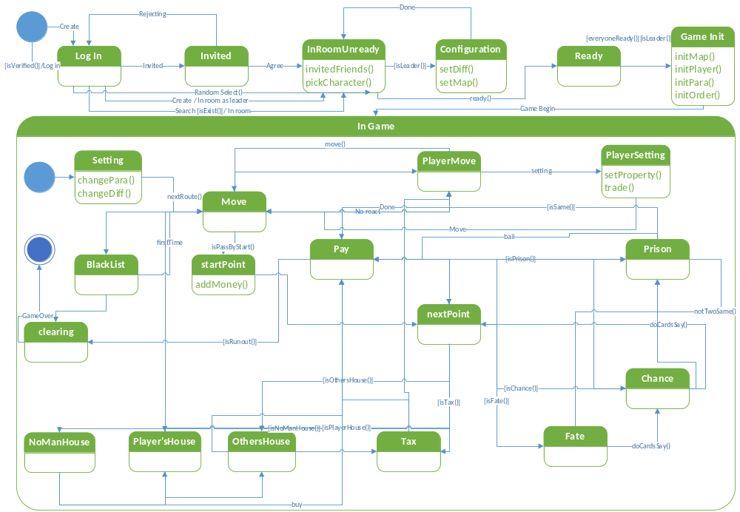

Appendix Ⅱ
Class Diagram
